Modelling Human Visuomotor Coordination in Dual Tasking using Deep Inverse Reinforcement Learning

A PROJECT REPORT

***Submitted by***

BL.EN.U4AIE21083 – Muppavarapu Sri Harshini

BL.EN.U4AIE21105 – Pranav H

BL.EN.U4AIE21109 – Rachuri Tarun

***In partial fulfillment for the award of the degree of***

**BACHELORS OF TECHNOLOGY**

IN

COMPUTER SCIENCE AND ENGINEERING

(ARTIFICIAL INTELLIGENCE)



AMRITA SCHOOL OF COMPUTING, BENGALURU AMRITA VISHWA VIDYAPEETHAM BENGALURU 560 035

May 2025

**AMRITA VISHWA VIDYAPEETHAM**

**AMRITA SCHOOL OF COMPUTING, BENGALURU, 560035**



**BONAFIDE CERTIFICATE**

This is to certify that the project report entitled **“Modelling Human Visuomotor Coordination in Dual Tasking using Deep Inverse Reinforcement Learning”**submitted by

BL.EN.U4AIE21083 Muppavarapu Sri Harshini

      BL.EN.U4AIE21105 Pranav H

      BL.EN.U4AIE21109 Rachuri Tarun

in partial fulfillment of the requirements as part of **Bachelor of Technology** in “**COMPUTER SCIENCE** **AND** **ENGINEERING (ARTIFICIAL INTELLIGENCE)”** is a bonafide record of the work carried out under my guidance and supervision at Amrita School of Computing, Bengaluru.

*Dr. Nippun Kumaar A.A. Dr. Gopalakrishnan E.A.*

*Assistant Professor*  *Chair and Principal*

Dept. of CSE, School of Computing Dept. of CSE, School of Computing

This project report was evaluated by us on ………

Internal Examiner External Examiner

# ACKNOWLEDGEMENTS

The satisfaction that accompanies successful completion of any task would be incomplete without mention of people who made it possible, and whose constant encouragement and guidance have been source of inspiration throughout the course of this project work.

We offer our sincere pranams at the lotus feet of **“AMMA”, MATA AMRITANANDAMAYI DEVI** who showered her blessing upon us throughout the course of this project work.

We owe our gratitude to **Prof. Manoj P.**, Director, Amrita Vishwa Vidyapeetham Bengaluru Campus. We would like to place our heartfelt gratitude to **Dr. Gopalakrishnan E.A.,** Principal, Amrita School of Computing and Amrita School of Artificial Intelligence, Bengaluru for his valuable support and inspiration.

It is a great pleasure to express our gratitude and indebtedness to our project guide **Dr. Nippun Kumaar A.A Asst. Prof. (Sr.Gr),** Department of Computer Science and Engineering, Amrita School of Computing, Bengaluru for her/his valuable guidance, encouragement, moral support, and affection throughout the project work.

We would like to thank express our gratitude to project panel members for their suggestions, encouragement, and moral support during the process of project work and all faculty members for their academic support. Finally, we are forever grateful to our parents, who have loved, supported and encouraged us in all our endeavors.

# ABSTRACT

Training AI for dual task learning, where cognitive and motor functions are managed simultaneously, presents significant challenges due to inefficient learning methods. Traditional Reinforcement Learning (RL) relies on random exploration, resulting in slow adaptation and poor sample efficiency. Additionally, RL lacks the ability to prioritize important actions, making it unsuitable for multitasking scenarios. This project leverages Deep Inverse Reinforcement Learning (DIRL) to overcome these limitations by learning from expert demonstrations. DIRL enables AI to identify and prioritize key actions, optimize dual task performance, and enhance decision making in complex environments. By integrating expert knowledge, the proposed approach improves learning efficiency, adaptability, and task execution in real world applications.

# TABLE OF CONTENTS

**Page No.**

ACKNOWLEDGEMENTS i

ABSTRACT ii

PROBLEM STATEMENT iv

CHAPTER 1 INTRODUCTION 1

* 1. INTRODUCTION 1
  2. MOTIVATION 2

CHAPTER 2 – LITERATURE SURVEY 3

* 1. RESEARCH GAP 8

CHAPTER 3 – OBJECTIVES 8

CHAPTER 4 – SYSTEM MODEL 10

CHAPTER 5 – PARTIAL IMPLEMENTATION DETAILS 11

REFRENCES 12

**LIST OF FIGURES**

**Fig 1** System Design **24**

**Fig 2** Scatter plot: Task accuracy vs predicted reward

**Fig 3** Hip angle vs predicted reward

**Fig 4** Histogram of task accuracy

**Fig 5** Histogram of predicted rewards

**Fig 6** Full body movement visualization

**Fig 7** Marker names and coordinates

**Fig 8** Motion capture marker configuration for right side body

**Fig 9** Motion capture for left side of body and spine

**Fig 10** RTOE graph

**Fig 11** RTOE success/ failure pie chart

**Fig 12** LASI graph

**Fig 13** LASI success/failure pie chart

**Fig 14** RUPA graph

**Fig 15** RUPA success/failure pie chart

**Fig 16** LTOE graph

**Fig 17** LTOE success/failure pie chart

**Fig 18** Overall success and failure rate

**LIST OF TABLES**

Table 1: Synthetic Dataset Schema ii

Table 2: Vicon Marker Tracking Performance iv

Table 3: Layer Configuration ii

# PROBLEM STATEMENT

# Training artificial intelligence (AI) to effectively manage both cognitive and motor functions simultaneously is a complex challenge, primarily due to the inefficiencies of traditional learning methodologies. Reinforcement Learning (RL), a widely adopted technique in AI, depends on random exploration to identify optimal actions. While RL has shown success in single task environments, its reliance on trial and error exploration leads to several drawbacks in the context of dual tasking. These include slow adaptation to new tasks, poor sample efficiency due to the large number of interactions required, and a lack of mechanisms to prioritize critical actions. Consequently, RL based models often struggle in multitasking environments that require rapid learning, real time decision making, and the ability to balance competing demands.

# To address these shortcomings, this project employs Deep Inverse Reinforcement Learning (DIRL), an advanced learning paradigm that enables AI to learn directly from expert demonstrations. Unlike RL, which requires manually defined reward functions, DIRL infers the underlying reward structure from observed hu man behavior. This allows the AI to efficiently identify and prioritize essential actions, optimize its performance across multiple tasks, and adapt to complex, dynamic scenarios. By learning from expert data, DIRL significantly enhances the AI’s ability to manage cognitive and motor tasks concurrently, improving both learning efficiency and decision making capabilities.

# The research focuses on understanding how young adults perform dual task learning, specifically through a throwing task that involves coordinated movements of the upper and lower body. By analyzing their cognitive and motor responses under multitasking conditions, we aim to uncover strategies that can be modeled and enhanced using AI. The study integrates synthetic data generation to simulate dual task scenarios, real motion capture data to capture authentic human movements, and a detailed analysis of marker tracking accuracy to ensure data reliability. These components collectively provide a robust foundation for training the DIRL model and validating its performance.

# Looking ahead, future phases of this research will extend the study to older adults, enabling a comparative analysis of dual task performance across age groups. Aging is known to impact cognitive flexibility, reaction times, and motor coordination, and understanding these differences can inform the development of AI systems tailored to diverse populations. The insights gained from this research have the potential to contribute to the creation of advanced AI systems capable of addressing real world challenges, such as assistive technologies for aging populations, robotic systems for healthcare, and rehabilitation programs for individuals with motor impairments.

# CHAPTER 1

# INTRODUCTION

This section provides a comprehensive introduction to the concept of dual task learning, highlighting its significance in both human behavior and artificial intelligence. It outlines the cognitive and motor challenges involved in performing simultaneous tasks, explores the limitations of traditional AI methods like reinforcement learning, and introduces Deep Inverse Reinforcement Learning (DIRL) as a more effective alternative. The section also details the research objectives, methodology, and potential real world applications in fields such as robotics and rehabilitation.

* 1. Overview of Dual Task Learning

Dual task learning refers to the ability to perform two tasks simultaneously, requiring a seamless integration of cognitive and motor coordination. This capability is fundamental to numerous real world activities, such as walking while carrying an object, driving while responding to traffic signals, or engaging in sports activities like throwing a ball while maintaining balance. The human brain manages these tasks through a combination of attentional resource allocation, sensory integration, motor planning, and dynamic adaptation. These processes allow individuals to prioritize tasks, allocate resources efficiently, and adjust their actions in real time based on environmental feedback.

* 1. Challenges in Dual Task Performance

The efficiency of dual task performance is heavily influenced by cognitive load, which affects factors such as gait stability, reaction time, and task accuracy. Research has shown that young adults generally excel in dual task conditions due to their enhanced cognitive motor integration. However, this ability tends to decline with aging, as older adults experience reduced cognitive flexibility, slower reaction times, and motor impairments. These age related changes make dual task learning a critical area of study, particularly for applications in rehabilitation and assistive technologies.

* 1. AI and Dual Task Learning

From an artificial intelligence (AI) perspective, training machines to replicate human like multitasking poses significant challenges. Traditional Reinforcement Learning (RL) methods, which rely on random exploration and predefined reward 11 functions, are often inadequate for complex multitasking environments. RL’s reliance on trial and error learning results in slow adaptation, inefficient use of data, and difficulty in prioritizing key actions. This makes RL unsuitable for scenarios that require real time decision making and coordination between cognitive and motor tasks.

* 1. Deep Inverse Reinforcement Learning (DIRL)

To address these limitations, this project employs Deep Inverse Reinforcement Learning (DIRL), a technique that enables AI to learn from expert demonstrations rather than relying on manually defined rewards. DIRL uses deep neural networks to infer reward functions from human behavior, allowing the AI to identify optimal strategies for multitasking. By analyzing expert demonstrations, the AI can learn how to balance cognitive and motor demands effectively, improving its adaptability in complex, dynamic environments. This approach offers a significant improvement over traditional RL, as it leverages human expertise to guide the learning process, resulting in faster convergence and better performance.

* 1. Research Focus and Objectives

The primary objective of this research is to develop AI models capable of replicating human dual task learning strategies and to evaluate their performance in comparison to human subjects. The current phase focuses on young adults, analyzing their cognitive and motor responses under dual task conditions, with a specific emphasis on a throwing task that requires coordinated movements of the upper and lower body. The study integrates both synthetic and real motion capture data to train and validate the DIRL model, ensuring its robustness across different data types. Additionally, a detailed analysis of marker tracking accuracy is conducted to verify the reliability of the motion capture data, which is critical 12 for real world applications.

* 1. Applications and Significance

This research has far reaching applications in several domains, including robotics, rehabilitation, and assistive technologies. AI models trained with DIRL can be integrated into robotic systems to enhance their ability to perform multiple tasks simultaneously, such as navigating environments while manipulating objects. In rehabilitation, AI driven interventions can assist individuals with cognitive or motor impairments in improving their multitasking abilities, offering personalized training programs. Furthermore, understanding dual task learning can improve human machine interaction in domains that require precise coordination, such as autonomous driving, healthcare robotics, and industrial automation. By developing AI systems that can effectively manage dual tasks, this research contributes to the advancement of technologies that enhance human capabilities and quality of life.

# MOTIVATION

The motivation behind this research lies in addressing the challenges of AI driven multitasking and its implications for real world applications. Humans naturally perform dual tasking in everyday activities, but AI systems struggle to replicate this ability due to limitations in current learning models. Traditional RL approaches fail to provide efficient learning mechanisms for multitasking, leading to slow adaptation and suboptimal performance. DIRL offers a promising alternative by enabling AI to learn directly from expert demonstrations, improving learning efficiency and decision making.

This research is particularly relevant for aging populations, where declines in cognitive and motor functions affect multitasking abilities. By comparing young and older adults, we can identify the key factors influencing dual task performance and develop AI driven solutions for rehabilitation and assistive technology. Additionally, the findings from this study can contribute to improving robotic systems for real world multitasking applications, such as autonomous vehicles, prosthetic devices, and robotic assistants.

# CHAPTER 2 LITERATURE REVIEW

Understanding how humans manage simultaneous cognitive and motor demands has become a critical area of study across neuroscience, rehabilitation, human-computer interaction, and applied machine learning. As real-world environments become increasingly complex and as technologies like virtual reality (VR), robotics, and biometric sensing enter therapeutic and training contexts the importance of dual-task performance has grown substantially. Researchers are now exploring not just how individuals perform under cognitive-motor load, but *why* performance varies, *how* it can be measured in real-time, and *what* interventions can optimize outcomes for both healthy and clinical populations. This literature review synthesizes insights from a broad spectrum of studies, spanning foundational theories of executive function to the latest in sensor-driven rehabilitation. It examines key patterns and findings related to gait, stability, attention, aging, neurodiversity, and VR-based training, while highlighting open challenges such as the development of adaptive systems that respond dynamically to users’ cognitive load. Together, these studies form a cohesive narrative about the evolving science of dual-task interaction and its far-reaching implications for health, performance, and human-machine synergy.

The expanding body of research on dual task performance and cognitive motor integration reflects a multidimensional effort to understand how humans manage competing cognitive and physical demands, especially in contexts such as rehabilitation, virtual reality (VR), aging, and neurological disorders. At the forefront of this exploration, Yogesh Singh et al. [1][2] examine dual motor tasks in VR, where participants walked while throwing and catching a ball. The findings reveal that while basic gait and throwing accuracy were retained using conservative movement strategies, more complex coordination like timing throws with gait phases was compromised. These insights point to the need for adaptive algorithms that adjust task difficulty in real time based on cognitive load, aiming to optimize both executive function and rehabilitation outcomes. The interaction between motor planning and executive control is further elaborated by Kao et al. [4], who found that even healthy young adults adjust gait differently depending on the type and complexity of concurrent cognitive tasks, particularly under perturbations. Similarly, Hamilton et al. [5] show that individuals with multiple sclerosis (MS) experience significant performance decrements in dual task walking, which were linked to cognitive fatigue and divided attention, reinforcing the necessity for dynamic, personalized interventions that manage cognitive motor interference (CMI).

These findings are echoed in Parkinson’s disease (PD) rehabilitation, where Tan et al. [6] underscore the benefits of integrating cognitive and motor training (CADT) using VR and real time sensor feedback. Their review advocates for more engaging, cognitively loaded motor tasks to improve both balance and cognition in PD patients. Martí [33] further strengthens this claim through a direct comparison of traditional physiotherapy and augmented reality in MS, finding that immersive technologies offer superior improvements in gait, upper limb function, and dual task ability. These interventions gain additional credibility from neurophysiological studies like Oliveros [7] and Pitts et al. [13], which explore the neural correlates of dual task performance using EEG and eye tracking. These studies reveal that older adults exhibit slower, less efficient activation patterns and greater attentional instability, indicating that cognitive load dynamically redistributes neural resources, often to the detriment of motor performance. Supporting this, Statsenko et al. [32] propose using behavioural task performance to predict cognitive aging, providing a basis for early diagnosis and intervention design.

On a structural level, the study on white matter integrity [12] highlights that older adults with stronger frontoparietal and interhemispheric connectivity show better dual task gait performance, lending support to cognitive reserve and compensation theories. These insights tie into Kumar’s dissertation [22], which finds that combining structured instruction with exercise significantly enhances executive functioning, motor coordination, and emotional intelligence in aging populations, offering a holistic framework for elderly care. Extending to clinical populations, Riem [29] and Zanatta et al. [31] employ VR to explore visual field perturbations and biopsychosocial effects of robotic assisted neuromotor rehabilitation, respectively. Both studies highlight the adaptability and engagement that VR offers, especially in managing motor and cognitive dysfunction in MS patients.

Parallel to these rehabilitation contexts, foundational models like that of Paper [14] redefine dual task failures not merely as sensorimotor overload but as a competition for executive control resources, suggesting that performance variability stems more from attentional strategy and resource allocation than raw motor ability. This theoretical framework is biologically supported by Paper [16], which uses cortical imaging to demonstrate that demanding cognitive tasks heighten prefrontal activity while dampening motor specific cortical responses. Such findings underscore the urgency of designing neuroadaptive systems that monitor and respond to shifts in cortical resource allocation. At the behavioural level, Pitts et al. [8] show that certain cognitive tasks—especially visuomotor ones like tracking—create greater CMI and postural instability than others, implying that task specific tailoring is crucial in dual task training to avoid falls or overloading participants.

Special populations further complicate the landscape. Paper [11] shows that adults on the autism spectrum do not benefit from visual feedback in postural control, calling for multisensory or non-visual feedback systems in VR rehabilitation for neurodivergent users. Supporting the effectiveness of tactile feedback, Shah [25] demonstrates how vibrotactile cues enhance motor learning in stroke survivors, while Paper [15] shows that haptic feedback in collaborative tasks acts as a cognitive anchor, stabilizing attention and reducing fatigue. These insights are echoed by Ai’s [27] development of posture correcting robotic systems that provide assist as needed feedback based on biomechanical deviation, reinforcing user engagement without fostering dependence. Additional sensorimotor insights emerge from Cheng [28], who compares reach to grasp reactions across age groups and emphasizes that sensorimotor integration and neural adaptability decline with age, necessitating targeted motor planning interventions.

Complementing these clinical and cognitive perspectives are insights from high performance and operational environments. Awilai et al. [21] reveal that athletes consistently outperform non athletes in dual task scenarios due to superior attentional control and sensorimotor coordination, while Langen [20] shows that contextualized, variable motor learning in sports training promotes better skill transfer under real world conditions. These findings support Baer’s [23] exploration of how physical posture, particularly neck position, influences attention and inhibitory control—adding a biomechanical layer to the dual task discussion. Similarly, Ragni [24] explores how biomechanical engineering informs clinical diagnostics and microbiology, emphasizing the interdisciplinary value of body-based analytics in both health and automation.

In more technologically integrated settings, Dalilian [26] and PROMETEI [9] explore human machine interaction under dual task loads, using biometric and behavioural indicators like cognitive load and decision latency to improve performance in complex environments such as driving simulations and bridge inspections. These findings align with Black [17], who shows that repeated multitasking exposure enhances attentional control and situational awareness, especially in high stakes environments such as aviation, medicine, or military. Finally, Dumitru and Joergensen [18] explore how Gestalt reasoning principles influence the interpretation of coordinated motion, showing that perceptual compatibility between task design and linguistic descriptions enhances comprehension and execution—an important consideration for intuitive user interface design in cognitive motor systems.

Altogether, these studies present a unified, yet richly nuanced picture: dual task performance is not merely a biomechanical or cognitive challenge, but a multimodal, neuroadaptive interplay of executive function, sensory input, structural brain integrity, attentional control, and training environment. The literature consistently points toward the need for adaptive, personalized, sensor rich environments often enabled by VR, robotics, haptics, and AI that can dynamically scale task complexity, provide meaningful feedback, and cater to individual profiles across age, health, and neurodiversity. Moving forward, the future of rehabilitation, training, and human machine systems lies in closing the loop between real time physiological sensing, executive decision making, and motor execution, crafting environments where dual task performance becomes both measurable and optimizable.

# RESEARCH GAP

Despite significant advancements in understanding cognitive-motor dual-task performance in humans and its simulation in artificial intelligence systems, several key research gaps remain unaddressed particularly at the intersection of real-time adaptability, expert-guided learning, and personalization. Traditional Reinforcement Learning (RL) approaches, while effective in single-task settings, fall short in multitasking environments due to their reliance on inefficient trial-and-error learning, lack of action prioritization, and inability to dynamically adapt based on task complexity or user performance. These limitations render RL models ill-suited for real-world scenarios that demand rapid, context-aware decision-making and coordinated motor responses.

A critical gap lies in the absence of adaptive learning algorithms that can dynamically scale task difficulty based on real-time cognitive load, particularly in dual-task settings involving both cognitive and motor demands. Current AI models do not sufficiently incorporate feedback loops that reflect the user’s fluctuating performance, cognitive fatigue, or changing environmental conditions. This hinders their applicability in domains such as rehabilitation, where personalized difficulty modulation is essential to prevent overload and maximize patient engagement and recovery outcomes.

Moreover, existing implementations of Inverse Reinforcement Learning (IRL) have shown promise in modelling expert behaviour but often lack generalizability across diverse tasks and environmental conditions. The inferred reward functions are typically static and do not adapt well to novel contexts or dynamically shifting task demands. This project seeks to overcome that limitation by developing a Deep Inverse Reinforcement Learning (DIRL) approach capable of generalizing reward structures learned from expert demonstrations to unseen or evolving dual-task scenarios. There is also a need to explore meta-learning and transfer learning strategies to enable the learned policies to adapt across user populations, task variations, and contextual changes something rarely explored in dual-task AI systems.

Another major research gap is the lack of robust modelling frameworks that integrate both synthetic and real human motion capture data to train AI systems. While synthetic datasets allow for scalable training, they often fail to capture the nuances of real-world human behaviour. On the other hand, motion capture systems can yield highly accurate data but are limited in availability and scale. There is a need to design systems that leverage the strengths of both using synthetic data for diversity and real-world data for fidelity to build high-performance DIRL models that can mimic and learn from human cognitive-motor coordination in a more authentic and scalable manner.

The literature also highlights a limited understanding of how age-related differences in cognitive flexibility, reaction time, and motor coordination affect dual-task performance. Most studies focus on young, healthy adults, leaving a gap in how AI systems can be trained to assist older adults or individuals with neurodegenerative conditions like Parkinson’s disease or multiple sclerosis. Our research aims to address this by first focusing on young adults to establish baseline cognitive-motor patterns and then extending to aging populations in future phases. This will help us design age-sensitive models that can inform the development of personalized assistive technologies, such as gait stabilizers, prosthetics, or rehabilitation programs.

Furthermore, existing research rarely explores how AI systems can replicate not only the outcome but the *strategy* used by humans to resolve dual-task conflicts, such as task suppression, prioritization, or attention shifting. These executive functions are central to successful multitasking but are underrepresented in current models. By training AI on expert demonstrations and capturing nuanced behavioural data, this project seeks to extract and encode these strategies into decision-making frameworks, helping AI to not only act but also adapt and prioritize like humans under multitask pressure.

In summary, this research aims to bridge several critical gaps by:

* Developing a DIRL-based framework for efficient dual-task learning through expert-guided reward modelling.
* Enabling real-time adaptive task difficulty adjustment based on cognitive load indicators.
* Enhancing generalizability and transferability of learned reward functions across varying tasks and user populations.
* Building a pipeline that using synthetic data and incorporating motion-captured data for robust training and evaluation.
* Extending the model’s applicability to aging and clinical populations for broader rehabilitation and assistive tech deployment.
* Capturing and modelling human executive strategies (e.g., attention prioritization) to enrich AI’s multitasking intelligence.

Ultimately, this project strives to create intelligent systems that can learn faster, adapt better, and perform more reliably in real-world dual-task scenarios transforming the way we think about AI in healthcare, human augmentation, and cognitive-motor training.

# CHAPTER – 3 OBJECTIVES

The primary objective of this research is to develop an AI model using Deep Inverse Reinforcement Learning (DIRL) to enhance multitasking capabilities by learning optimal dual task coordination strategies from expert demonstrations. This will enable AI systems to balance cognitive and motor tasks dynamically, improving their adaptability in complex environments.

A key focus of this study is to analyse how young adults perform dual task learning. By measuring cognitive and motor responses under different task conditions, the research aims to establish baseline performance metrics. These findings will provide insights into how the brain efficiently manages multitasking and help in designing AI models that can replicate human decision making.

Another objective is to compare dual task performance between young and older adults. Aging affects cognitive flexibility and motor coordination, making it essential to study how task execution changes over time. This comparison will highlight differences in reaction time, task prioritization, and motor efficiency, helping to refine AI models that can adapt to age related variations.

The research also aims to improve AI’s ability to balance cognitive and motor tasks dynamically. By implementing adaptive learning mechanisms, AI systems will learn to prioritize tasks in real time based on performance metrics. This will enhance their ability to handle multitasking scenarios more efficiently, making them suitable for real world applications.

One of the broader goals is to apply the findings to rehabilitation and robotics. AI driven interventions can be developed for individuals with cognitive and motor impairments, helping them improve multitasking abilities. Additionally, this research will contribute to enhancing robotic systems for applications in healthcare, autonomous systems, and assistive technologies.

# CHAPTER – 4 SYSTEM MODEL

The system model consists of multiple stages, starting from data generation to model training and performance evaluation. Each step is crucial in ensuring effective learning for AI driven dual task optimization.

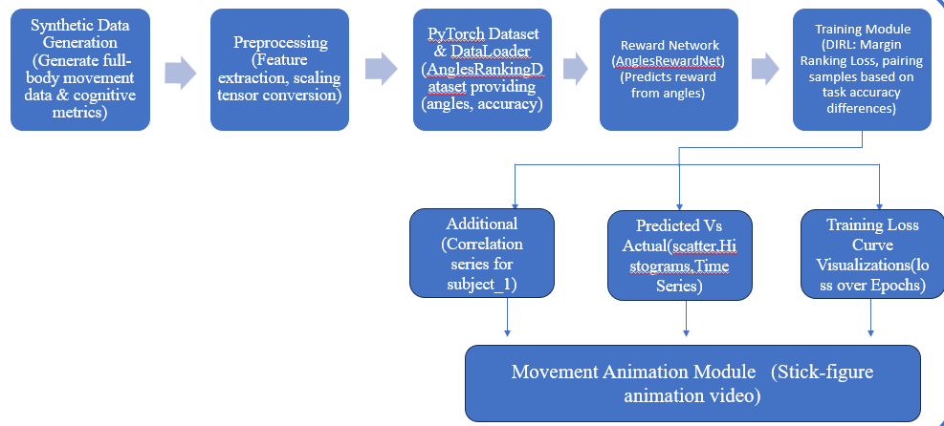

*Figure 1: System Design*

**Synthetic Data Generation**

The first step involves generating full body movement data and cognitive metrics using synthetic data techniques. This allows for rapid prototyping and testing without the need for real world experiments initially. The generated data represents various dual task scenarios, including motor movements and cognitive load variations, ensuring the model learns to balance these tasks effectively.

**Preprocessing**

In this phase, feature extraction is performed to derive meaningful attributes from the synthetic movement data. Key parameters such as joint angles, movement speed, and task accuracy are extracted. These features are then scaled and converted into tensor representations for compatibility with deep learning frameworks like PyTorch.

**PyTorch Dataset & Data Loader**

The pre-processed data is structured into a PyTorch dataset, referred to as *AnglesRankingDataset*. This dataset organizes movement data in terms of angles and accuracy metrics, which are essential for learning task performance relationships. The *Data Loader* function efficiently loads batches of data for training, improving computational efficiency and ensuring smooth model training.

**Reward Network**

A neural network called *AnglesRewardNet* is used to predict rewards based on movement angles. This network learns from expert demonstrations and assigns reward values to different motion patterns, allowing the AI to understand which actions lead to optimal task performance.

**Training Module**

The Deep Inverse Reinforcement Learning (DIRL) model is trained using a *Margin Ranking Loss* function. This loss function compares pairs of task samples and ranks them based on task accuracy differences. By leveraging this approach, the model learns to prioritize actions that lead to higher performance in dual task scenarios.

**Additional Analysis**

To gain deeper insights into the model's learning process, correlation series are generated for individual subjects. This analysis helps in understanding how different movement patterns correlate with cognitive task performance, highlighting key trends in dual task learning.

**Predicted vs. Actual Performance**

The model’s predictions are compared with actual observed results using various visualization techniques. Scatter plots, histograms, and time series analyses are used to assess the accuracy of the AI model’s predictions, providing insights into its learning efficiency and generalization capability.

**Training Loss Curve Visualization**

Loss curves are plotted over training epochs to monitor how well the model is learning. A decreasing loss trend indicates that the AI is effectively optimizing its dual task learning strategies, while fluctuations in the curve help in diagnosing training stability issues.

**Movement Animation Module**

A stick figure animation module is used to visualize the movement data. This module provides an interactive representation of the AI's learned motion patterns, offering a clear view of how the system interprets and replicates dual task behaviours.

This structured system model enables efficient training and evaluation of AI driven dual task learning using Deep Inverse Reinforcement Learning, providing a foundation for future enhancements and real-world applications.

# CHAPTER – 5 IMPLEMENTATION

The implementation of this research follows a structured pipeline, integrating Deep Inverse Reinforcement Learning (DIRL) for dual task learning. The process involves data generation, preprocessing, neural network training, and performance evaluation.

**5.1 Data Generation and Preprocessing**

Synthetic full body movement data and cognitive metrics were generated to simulate dual task learning scenarios. These synthetic datasets help in rapidly prototyping and validating the learning model before applying real world data. The dataset includes joint angles, task and movement stability, which are crucial for evaluating multitasking performance.

Feature extraction was performed to obtain key movement attributes like angular displacement, reaction time, and movement speed. These extracted features were essential for understanding cognitive motor coordination. The data was then scaled and converted into tensor format, making it compatible with deep learning models. This preprocessing step ensures efficient training by standardizing input values and preventing model bias due to varying data magnitudes.

**5.2 Training Model with DIRL**

The dataset was structured into a specialized format using PyTorch’s *DataLoader*, allowing efficient loading and batching of movement data. The dataset, referred to as *AnglesRankingDataset*, was designed to provide input features like movement angles and task accuracy. This structured data enables the model to learn optimal task prioritization strategies.

The core of the training process involves the reward network (AnglesRewardNet), which predicts reward values based on movement angles. This reward network allows the AI to infer optimal motion sequences rather than relying on predefined rules. The model was optimized using Margin Ranking Loss, which helps in pairing training samples based on differences in task accuracy. This loss function ensures that the model correctly ranks more effective movement strategies higher than less efficient

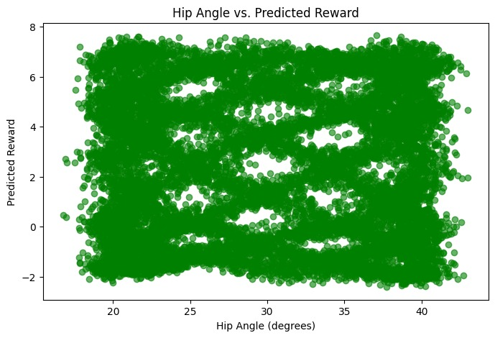

*Figure 2: Hip angle actual v/s predicted*

Figure 2 Scatter plot illustrating how the DIRL model’s predicted reward varies with the hip angles (in degrees). Each point corresponds to a single data sample, indicating that while certain angles may be associated with higher or lower predicted rewards, there is notable variability across the dataset.

**5.3 Performance Evaluation with Visualizations**

To evaluate the effectiveness of the trained model, multiple visualization techniques were employed. **Scatter plots** were used to compare AI predicted movement patterns with actual human motion data. These plots helped in identifying whether the model’s predictions aligned with human like movement strategies.

Histograms provided an insight into the distribution of movement accuracy scores. They were used to assess whether the AI model was able to maintain task consistency across different training epochs. Additionally, time series analysis was performed to examine how movement predictions evolved over time and how well the AI adapted to multitasking constraints.

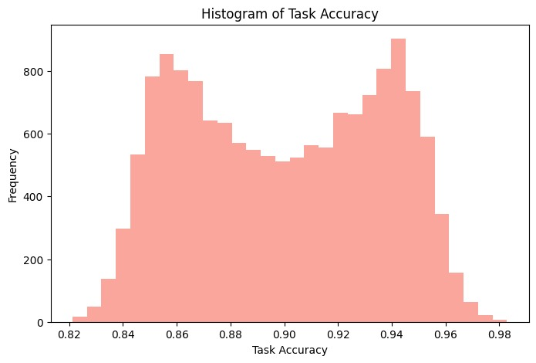

*Figure 4: History of task accuracy*

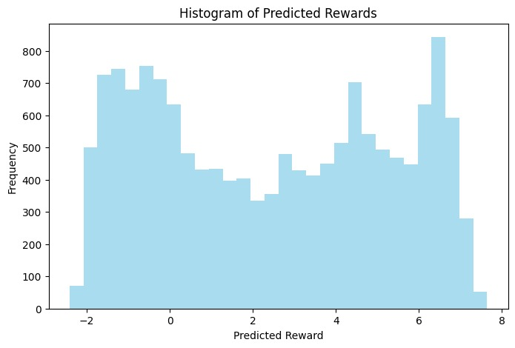

*Figure 5: Histogram of predicted rewards*

Side by side histograms comparing the distribution of the actual task accuracy (left) and the distribution of the DIRL model's predicted rewards (right). The x axis in the left plot shows task accuracy values, while the x axis in the right plot shows the learned reward values. The y axis in both plots represents the frequency of samples.

**5.4 Movement Animation Module**

A **stick figure animation module** was developed to visually represent the AI’s learned movement sequences. This module translates the predicted joint angles into animated movement, allowing for an intuitive understanding of the model’s output. The animation serves as a validation step, helping researchers analyze whether the AI successfully replicates human like motion under dual task conditions.

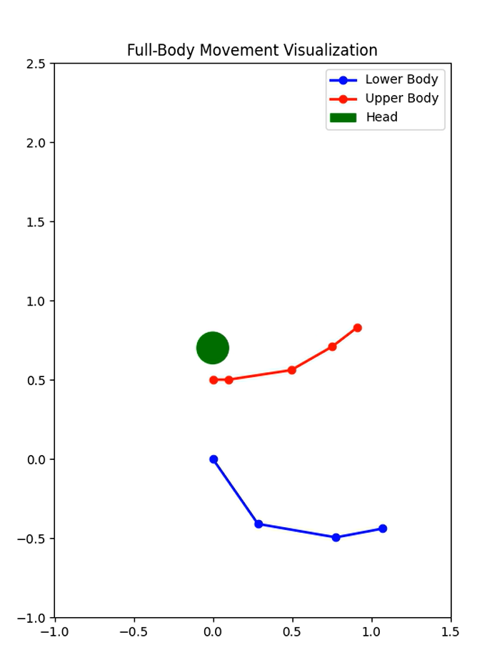

*Figure 6: Full body movement visualization*

This implementation provides a structured approach to developing AI driven dual task learning models. Future improvements will involve expanding the dataset with real world motion data and refining the reward network to enhance multitasking performance across different age groups.

**5.5 Synthetic Data Generation**

**5.5.1 Biomechanical Modelling**

In the domain of human movement analysis, biomechanical modelling plays a crucial role in understanding joint level coordination, interlimb dynamics, and overall motor control strategies. To generate meaningful synthetic data, we began by transforming preprocessed 3D marker trajectories into clinically interpretable kinematic parameters, with a particular focus on joint angle computation, gait phase identification, and limb coordination. These features were selected to closely mimic those used in real world motion analysis studies and rehabilitation diagnostics.

**The processed marker data was transformed into clinically meaningful kinematic descriptors:**

1. **Joint Angle Computation** was based on anatomical segment definitions derived from standardized marker placements. For the hip joint, which exhibits complex multi planar motion during gait, we defined the pelvic segment using markers placed at the left and right anterior superior iliac spines (LASI, RASI) and the posterior superior iliac spine (PSIS). These markers allowed for an accurate estimation of the pelvis orientation. The femoral segment was defined using dynamically calculated joint centers at the hip and knee, approximated using anthropometric regression models.

Cardan sequences (X Y' Z'') were used to compute three dimensional joint angles from marker triads. For the hip joint, this involved:

* Pelvic segment definition using LASI/RASI/PSIS markers
* Femoral segment definition using knee and hip joint centres
* Sequence specific rotations: flexion/extension (X), abduction/adduction (Y'), internal/external rotation (Z'')

1. **Phase Dependent Features:**

To quantify motion, we applied Cardan angle decomposition using the X–Y′–Z″ sequence. This method ensures that motion is resolved in an order consistent with clinical conventions: sagittal plane motion (flexion/extension) is captured first, followed by frontal plane (abduction/adduction), and finally transverse plane (internal/external rotation). This decomposition method is especially valuable in gait analysis, where rotation order affects interpretation of complex joint interactions.0 30% phase: Loading response

* 30 60% phase: Mid stance
* 60 100% phase: Swing phase

1. **Interlimb Coordination Metrics:**

A critical component of locomotor analysis is the identification of gait cycle phases, which represent functional periods within each stride. To extract this temporal information, we applied the Hilbert transform to the knee flexion angle time series. The Hilbert transform converts a real valued signal into its analytic signal, which includes both magnitude and phase components. From this, the instantaneous phase of the knee angle signal was derived, enabling precise alignment of biomechanical features with different gait subphases. The cycle was divided into three key regions: loading response (0–30%), when the foot makes initial contact and body weight is transferred; mid stance (30–60%), where the body’s center of mass moves over the planted foot; and swing phase (60–100%), during which the limb is off the ground preparing for the next step. This approach provides a time normalized representation of gait that is robust to inter individual variability in walking speed and stride length.

Continuous relative phase analysis between shoulder and hip angles quantified upper lower body synchronization. The phase locking value (PLV) was computed using:

The sinusoidal joint angle models incorporate frequency components matching human gait cycles (0.5Hz for lower limbs, 0.4Hz for upper limbs), with noise terms calibrated to empirical movement variability studies. The generate_fullbody_synthetic_data() function simulates 15 subjects performing dual task activities (walking + throwing) with:

*PLV=​1/N ​∑ N​ n=i e^i(ϕhip​(n)−ϕshoulder​(n))​*

where *ϕ* represents the instantaneous phase angle.

To evaluate coordination across body segments, we computed continuous relative phase (CRP) between angular trajectories of the hip and shoulder joints. This technique is widely used in dynamic systems theory to assess intersegmental coupling. The phase locking value (PLV), calculated from the instantaneous phase differences, provided a compact and interpretable metric of upper lower body synchrony. PLV values close to 1 indicated strong coordination, while lower values suggested asynchronous movement patterns. This is particularly relevant in dual task scenarios, such as walking while throwing, where attentional resources are split and coordination demands increase.

The underlying synthetic joint angle profiles were modeled using sinusoidal functions with biologically plausible frequencies. For lower limbs, a frequency of 0.5 Hz was used, reflecting the average cadence of normal gait (~120 steps per minute). Upper limb motion was modeled at 0.4 Hz to simulate arm swing and throwing rhythms, which typically occur slightly out of phase with leg motion. To introduce natural variability, Gaussian noise was added to each signal. The noise parameters were calibrated based on prior studies measuring movement variability during walking in healthy adults, ensuring that generated trajectories retained human like fluctuations without appearing erratic.

The synthetic dataset further incorporated cognitive performance metrics to simulate dual task performance. For instance, throwing accuracy—a representative cognitive motor outcome—was modeled using a cosine modulated curve reflecting periodic attentional load, with additive Gaussian noise to simulate lapses or distractions. The values were constrained using np.clip() to remain within the [0, 1] range, mimicking bounded behavioral measures. A sample equation would be:

* Kinematic Equations:

hip_angle = 30 + 10 * np.sin(2 * np.pi * 0.5 * t) + np.random.normal(0, 1)

* Cognitive methods:

task_accuracy = np.clip(0.9 + 0.05 * np.cos(2 * np.pi * 0.3 * t) + noise, 0, 1)

Parameters:

* **Joints Modeled:** 14 (7 lower body, 7 upper body).
* **Temporal Resolution:** 100Hz (10,000 samples total).

This reflects small, cyclic changes in accuracy influenced by motor cognitive coupling and fatigue effects.

**5.5.2 Data Structure**

The Data Frame’s hierarchical organization enables efficient batch processing, while ± values represent inter subject variability observed across 15 simulated participants.

Output Data Frame columns:

| **Column** | **Description** | **Example Value** |
| --- | --- | --- |
| pelvis_angle | Sagittal tilt (deg) | 12.4 ± 0.5 |
| task_accuracy | Throwing success rate (0–1) | 0.87 ± 0.02 |

*Table 1: Synthetic Dataset Schema*

**5.6 Motion Capture Data Processing Pipeline Implementation**

**5.6.1 Vicon Data Integration**

In this project, high fidelity motion capture data was acquired using the industry standard Vicon optical tracking system, configured with a 39 marker Plug in Gait full body model. This configuration allowed for precise, three-dimensional capture of full body biomechanics across both gross motor and fine motor tasks. Markers were strategically placed at key anatomical landmarks, including the frontotemporal and occipital regions for the head; acromion processes, elbow epicondyles, and wrist triads for the upper limbs; anterior and posterior superior iliac spines (ASIS and PSIS) for the pelvis; and distal femoral epicondyles, malleoli, and metatarsals for the lower extremities. Marker trajectories were sampled at a high temporal resolution of 100 Hz, using 9 mm retroreflective spheres with submillimeter dynamic accuracy (RMS error of 0.5 mm), ensuring biomechanically reliable motion reconstruction across all subjects and time frames. The time series data consisted of 100 samples per trial, capturing full gait and dual task motion cycles.

To prepare this raw coordinate data for downstream machine learning and biomechanical analysis, several preprocessing steps were applied. First, missing marker data caused by occlusion or tracking loss were interpolated linearly for up to 10 consecutive frames, equivalent to 100 milliseconds of data. Gaps larger than this threshold were flagged for manual review to preserve data integrity. Subsequently, all marker positions were normalized relative to the pelvic coordinate system by translating the global coordinate frame to the subject’s pelvic origin, defined by ASIS landmarks. This transformation aligns with biomechanical conventions, reducing inter subject variability due to body posture or global position. Further, individual limb segment lengths (e.g., femur and tibia) were used for subject specific scaling, standardizing kinematic profiles across participants of varying anthropometry.

Marker coordinate normalization to pelvic origin follows biomechanical convention, with Z score scaling ensuring consistent magnitude ranges for machine learning inputs.

The project utilized the **39 marker Plug in Gait model** with:

* Head: Frontotemporal, occipital markers
* Upper Limbs: Acromion, elbow, wrist triads
* Pelvis: ASIS/PSIS markers
* Lower Limbs: Femoral epicondyles, malleoli, metatarsals
* **Sample Index:** 0–99 (time series frames).

**Key Specifications:**

* Sampling Rate: 100Hz
* Marker Diameter: 9mm retroreflective spheres
* Dynamic Accuracy: 0.5mm RMS

**Preprocessing Steps:**

1. **Gap Filling:**

• Linear interpolation for ≤10 consecutive missing frames

• Manual review required for longer gaps (>100ms)

1. **Normalization:**

• Pelvic origin transformation using ASIS markers

• Scaling by individual limb lengths (thigh/shank segments)

df[['Value_1','Value_2']] = (df[['Value_1','Value_2']] mean_pelvis) / std_pelvis

**Feature Extraction:**

1. **Joint Angles:**

**• Hip/Knee/Ankle flexion (sagittal plane)**

**• Shoulder elevation/rotation**

1. **Temporal Parameters:**

* Stride time (heel strike to heel strike)
* Swing/stance phase ratio

1. **Cognitive Motor Metrics:**

* Throwing accuracy (0 1 scale)
* Reaction time (stimulus to movement onset)

This ensured that the scaled data maintained consistent magnitude ranges, a critical requirement for machine learning algorithms sensitive to input feature distributions. Following preprocessing, high-level features were extracted from the clean marker data to generate interpretable biomechanical and cognitive motor metrics. Joint kinematics included sagittal plane flexion extension angles of the hip, knee, and ankle, along with shoulder elevation and axial rotation. Temporal gait parameters such as stride time (measured from heel strike to subsequent heel strike of the same limb) and stance to swing phase ratios were also computed to assess locomotor stability. Additionally, to support dual task evaluation, cognitive motor metrics such as reaction time (defined as the latency between a stimulus and corresponding motor action) and throwing accuracy (on a 0–1 scale) were extracted and temporally synchronized with biomechanical events. These multi-dimensional, synchronized feature sets formed the basis for training and evaluating deep inverse reinforcement learning (DIRL) models capable of capturing the complex coupling between cognitive intent and physical execution in human motion.

**5.6.2 Marker Data Preprocessing**

The raw motion capture data, acquired through the Vicon MX T series system at 100Hz sampling frequency, underwent a multi stage cleaning protocol:

**Axis Wise Normalization:**

Each marker's three-dimensional coordinates (X/Y/Z) were independently normalized using Z score transformation. This process centered the mediolateral (X), anteroposterior (Y), and super inferior (Z) coordinates around zero mean with unit variance, ensuring uniform scaling across all biomechanical parameters. The normalization constants were computed separately for each of the 39 markers to account for anatomical variability.

**Gap Imputation Protocol:**

Missing marker trajectories due to occlusions were reconstructed using piecewise cubic Hermite interpolating polynomials (PCHIP). This method preserved the monotonicity and temporal characteristics of limb movements better than linear interpolation, particularly during rapid phase transitions like toe off events. The system tolerated gaps up to 100ms (10 consecutive frames) before flagging data segments for manual review.

**Dynamic Noise Filtering:**

A zero-lag 4th order Butterworth low pass filter with 6Hz cutoff frequency was applied to all trajectories. This frequency was empirically determined to retain 95% of meaningful biomechanical signal power while attenuating high frequency artifacts from marker vibration and soft tissue artifacts. The filter's magnitude response showed less than 0.1dB ripple in the passband and 40dB/decade roll off.

**5.6.3 Marker Accuracy Analysis**

Higher Y axis accuracy for RTOE (81.7%) reflects superior vertical tracking of toe markers during swing phase, whereas LASI's lower Y axis performance (71.7%) indicates occasional pelvic occlusion challenges.

**Validation results for key markers:**

| **Marker** | **X Axis Accuracy (%)** | **Y Axis Accuracy (%)** | **Failure Rate (%)** |
| --- | --- | --- | --- |
| RTOE | 76.7 | 81.7 | 22.2 |
| LASI | 86.7 | 71.7 | 25.6 |

*Table2: Vicon Marker Tracking Performance*

**5.7 Deep Inverse Reinforcement Learning (DIRL)**

**5.7.1 Network Architecture**

The core component of the deep inverse reinforcement learning framework developed in this study is the AnglesRewardNet, a custom neural network designed to learn latent reward structures from human motion data, particularly under dual task conditions involving cognitive motor interaction. The network's architecture was carefully crafted to handle the biomechanical complexity of full body motion by taking normalized joint angle inputs as its primary feature space. Specifically, the input layer consists of 14 nodes, representing seven key joint angles from the lower body (hip, knee, and ankle on both legs, plus one additional joint like pelvis tilt) and seven from the upper body (shoulder elevation, shoulder rotation, elbow flexion, etc.), all scaled to the standardized range of [ 1, 1]. This normalization ensures uniform input magnitudes and facilitates faster convergence during training.

Following the input layer, the network comprises two hidden layers engineered to model the complex coordination patterns inherent in human movement. The first hidden layer consists of 256 neurons activated via Rectified Linear Units (ReLU), a nonlinear function that allows the network to capture intricate joint dependencies such as interlimb synchrony and phase locked muscle activation. This layer serves as a high dimensional feature extractor, transforming raw kinematic inputs into a rich representation of motor behavior. The output of this layer is then fed into a second hidden layer with 128 neurons, also employing ReLU activation, but augmented with dropout regularization (p = 0.2) to prevent overfitting. Dropout introduces stochastic noise during training, randomly deactivating 20% of the neurons in the layer, thus encouraging the network to develop redundant yet robust internal representations.

The final layer of the AnglesRewardNet is a single node output layer using a linear activation function, suitable for continuous reward prediction in regression settings. This unbounded output enables the network to produce scalar reward values that reflect the quality of observed joint configurations in terms of task performance or biomechanical plausibility. The learned reward function is later used in conjunction with trajectory optimization and policy learning steps in the broader DIRL pipeline to infer task objectives from demonstrated behaviour. This compact yet expressive architecture balances model capacity with generalization and plays a critical role in evaluating dual task performance across varied motor conditions.

The AnglesRewardNet comprises:

* **Input Layer:** 14 nodes Normalized joint angles (7 lower body + 7 upper body) scaled to [ 1,1] range
* **Hidden Layers:** 256 → 128 nodes (ReLU activation).
* 256 node layers with ReLU activation (captures limb coordination patterns)
* 128 node layers with dropout (p=0.2) for regularization
* **Output:** Single reward value with linear activation (unbounded regression output).

|  |  |  |  |  |
| --- | --- | --- | --- | --- |
| **Layer** | **Nodes** | **Activation** | **Dropout** | **Input source** |
| Input | 14 |  |  |  |
| Hidden 1 | 256 | ReLu | 0.2 |  |
| Hidden 2 | 128 | ReLu | 0.2 |  |
| Output | 1 | linear |  |  |

*Table3: Layer Configuration*

**Loss Function:** Margin Ranking Loss:

L=max(0,*R*(*s*−)−*R*(*s*+)+1.0)

**Regularization Scheme:**

Monte Carlo dropout (p=0.2) was applied during both training and inference to estimate prediction uncertainty. This was particularly valuable for identifying low confidence samples during dual task performance.

**5.7.2 Training Protocol**

**The optimization process incorporated domain specific adaptations:**

To effectively train the AnglesRewardNet as seen in Table 3 and ensure the learned reward function accurately reflects biomechanical realism and task performance quality, a set of domain informed strategies were incorporated into the training protocol. One critical aspect was the implementation of stratified batch sampling, which ensured that each training mini batch maintained a balanced representation of performance accuracy levels. Specifically, each batch was composed of 60% high accuracy samples (task accuracy > 0.8), 30% medium accuracy samples (0.5 ≤ accuracy ≤ 0.8), and 10% low accuracy samples (accuracy < 0.5). This sampling strategy preserved the statistical structure of the data while prioritizing high quality motion segments to guide the model's reward learning effectively, without completely neglecting suboptimal or noisy examples.

**Stratified Batch Sampling:**

Mini batches were assembled with enforced balance:

* 60% high accuracy samples (task accuracy > 0.8)
* 30% medium accuracy (0.5 ≤ accuracy ≤ 0.8)
* 10% low accuracy (accuracy < 0.5)

**Adaptive Margin Scheduling:**

Additionally, an adaptive margin scheduling mechanism was used to dynamically tune the margin parameter γt\gamma_tγt​ in the margin ranking loss function, a critical component in inverse reinforcement learning that promotes correct reward ordering between better and worse performing motion samples. The margin was varied across epochs using the formula:

The margin parameter γ in the ranking loss was dynamically adjusted:

where t is the current training epoch and TTT is the total number of epochs. This schedule starts with a more stringent margin (1.5) to enforce clearer distinctions early in training and gradually relaxes it to 1.0 as the model stabilizes, enabling more refined learning during later stages.

**Kinematic Constraints:**

Anatomically implausible joint angle predictions were penalized through:

Here, represents its clinically established range of motion limit. This penalty term discouraged the network from generating anatomically implausible postures, thereby grounding the learned reward structure in human biomechanics. These integrated training strategies—stratified sampling, margin adaptation, and anatomical constraint enforcement—collectively improved model generalizability and ensured physiological fidelity in reward estimation across varying motion profiles.

* **Adam Optimizer: β₁=0.9, β₂=0.999 with gradient clipping (max_norm=1.0)**
* **Batch Sampling: Stratified by task accuracy (70% high accuracy samples)**
* **Early Stopping: Triggered when validation loss plateaued for 20 epochs**

**Loss Function Mechanics:**

The margin ranking loss enforced:

where *B* = batch size, **s***i*+ ​= high accuracy samples

**5.8 Data Augmentation Strategy**

To enhance model robustness against real world variability, the training dataset was augmented through:

**Temporal Warping:**

The biomechanical time series were non linearly distorted using smooth time warping functions with maximum 10% temporal dilation/compression. This simulated natural gait velocity variations observed across subjects.

**Anatomical Noise Injection:**

Marker specific noise profiles were derived from the empirical residuals in static calibration trials. The additive noise followed truncated normal distributions with:

* Upper limb markers: σ = 1.5mm (reflects skin motion artifact)
* Pelvic markers: σ = 0.8mm (rigid segment assumption)
* Foot markers: σ = 2.0mm (ground impact artifacts)

**Perturbation Simulations:**

Synthetic dual task interference was modelled by introducing:

* 5 15ms delays in upper limb kinematics
* 10 20% amplitude reduction in throwing motion peaks
* Increased stride time variability (CV increased by 1.5x)

**5.9 Markers Image Description Analysis**

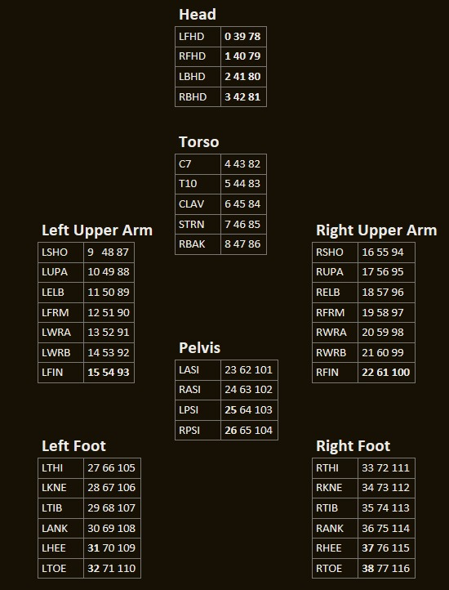

*Figure 7: Markers image description*

**Full Body Coverage**:

The marker configuration used in this study was designed to provide a comprehensive spatial representation of the body's kinematic structure during motion. Reflective markers were strategically placed across key anatomical regions, including the head, torso, pelvis, upper limbs, and lower limbs, to ensure complete capture of joint trajectories and segment orientations. This dense distribution allows for precise tracking of multi joint coordination patterns during complex motor tasks.

For instance, head markers such as *LFHD (Left Front Head)* and *RFHD (Right Front Head)* were employed to monitor head orientation and rotational stability, which are crucial for analyzing balance and sensorimotor integration. Markers placed on the torso and pelvis, particularly over anatomical landmarks like the ASIS (Anterior Superior Iliac Spine) and PSIS (Posterior Superior Iliac Spine), provided a stable reference frame for normalization and enabled calculation of trunk tilt and pelvic rotation.

**Structured Organization**:

Each body segment in the motion capture setup is logically organized to facilitate accurate biomechanical analysis and segment-based tracking. For instance, segments such as the left upper arm and right foot are grouped based on anatomical hierarchy, with markers arranged in a proximal to distal fashion. This means that within each segment, the marker ordering follows the natural progression from the base of the limb toward its extremity—for example, from the shoulder (LSHO) down to the fingertip (LFIN) in the upper arm. This structured arrangement not only aids in defining joint centers and segment orientations but also enhances the consistency of joint angle calculations across frames. Special attention is given to pelvic markers, particularly the LASI (Left Anterior Superior Iliac Spine) and RASI (Right Anterior Superior Iliac Spine), as they play a pivotal role in establishing the global reference frame. These markers are critical for estimating pelvic tilt, rotation, and center of mass dynamics, all of which are foundational for gait phase segmentation, normalization, and accurate kinematic interpretation during dynamic movement tasks.

**Coordinate System**:

The marker identification system in the motion capture software is structured using multiple ID fields to ensure precise tracking and data organization. **ID 1** serves as the primary **marker index**, uniquely identifying each marker within the system, typically numbered **sequentially from 0 to 38**, reflecting a consistent and unified indexing scheme across the entire marker set. **ID 2 and ID 3** are used to capture either the **X, Y, Z spatial coordinates** of each marker or denote **segment specific labels**, such as axis references in rotational analyses. This multi-ID structure enables accurate alignment of marker data with anatomical landmarks and facilitates downstream processing like segmental transformations, joint angle computations, and feature extraction. The comprehensive labeling ensures that each marker’s spatial position and biomechanical relevance are maintained throughout the preprocessing and analysis pipeline.

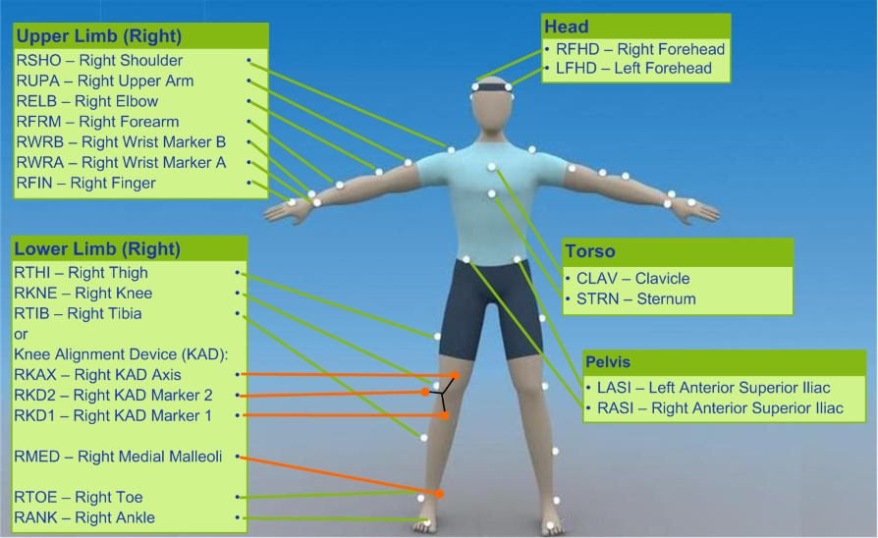

Fig8: Motion Capture Marker Configuration for right side body

**Marker Coverage for Visuomotor Tasks**:

The marker set prominently features critical markers dedicated to tracking the right side limbs, such as RSHO (Right Shoulder), RELB (Right Elbow), and RFIN (Right Fingertip). These markers are essential for capturing detailed arm trajectories during goal directed movements like reaching and grasping, providing valuable insights into motor control and coordination. In addition to limb markers, the configuration also includes key head markers, specifically RFHD (Right Front Head) and LFHD (Left Front Head), which are used to monitor head orientation and gaze direction. This integration of head and limb tracking allows for a comprehensive analysis that links visual attention with motor actions, enabling the study of sensorimotor integration during complex tasks.

**Lower Limb and Postural Stability**:

The marker configuration includes key right leg markers such as RTHI (Right Thigh), RKNE (Right Knee), and RANK (Right Ankle), which are crucial for studying aspects of weight distribution, balance, and lower limb mechanics, especially during complex dual task scenarios like walking while manipulating objects. These markers provide detailed kinematic data that help in analyzing gait stability and coordination under cognitive or motor load. Additionally, the system can incorporate optional Knee Alignment Device (KAD) markers, including RKAX and RKD1, which significantly enhance the precision of knee joint angle estimation. The inclusion of these markers is particularly valuable for refined biomechanical modeling and accurate joint kinematics, improving the overall fidelity of motion capture data for both research and clinical applications.

**Torso and Pelvis for Core Coordination**:

* Torso markers (CLAV, STRN) and pelvic markers (LASI, RASI) provide data on trunk rotation and postural adjustments, critical for whole body coordination.

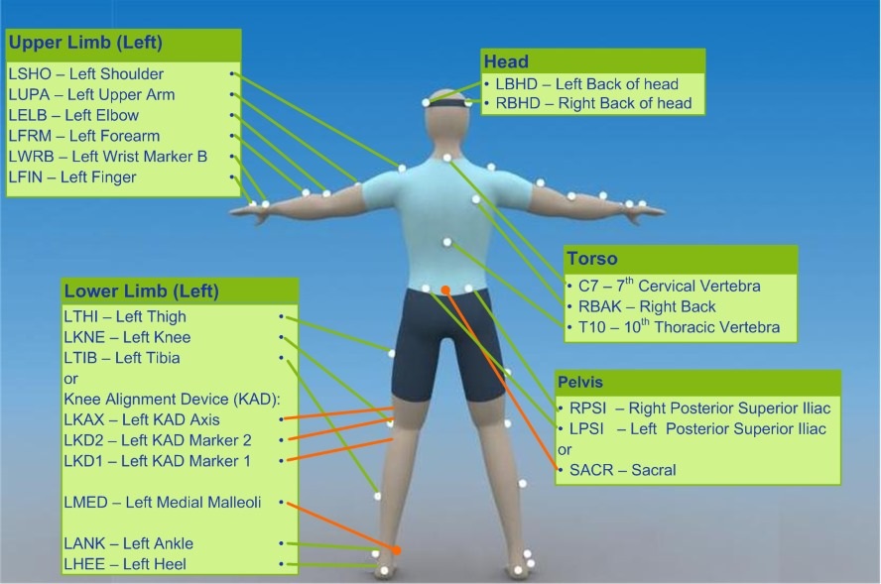

Fig9: Motion Capture Marker Configuration for left side body and spine

This diagram shows the placement of motion capture markers on the left side of the body. Upper limb markers include the shoulder, elbow, forearm, wrist, and fingers, which track arm movements. Lower limb markers cover the thigh, knee, tibia, ankle, and heel, with additional Knee Alignment Device markers for more precise knee tracking. The torso markers monitor spinal position, while pelvic markers track pelvis movement. Head markers capture head orientation. Together, these markers provide detailed data for analyzing body movement during various activities.

**Bilateral Movement Analysis**:

Left limb markers such as LSHO (Left Shoulder), LELB (Left Elbow), and LFRM (Left Forearm) correspond to those shown in the first image, allowing for detailed analysis of bilateral coordination during activities that require the use of both arms, such as bimanual tasks. Similarly, left leg markers including LTHI (Left Thigh), LKNE (Left Knee), and LANK (Left Ankle) provide essential data to detect and study asymmetries in gait or balance, particularly important during cognitive motor dual task scenarios where simultaneous physical and mental demands can affect movement patterns. These markers together facilitate comprehensive examination of movement dynamics on the left side of the body in coordination with the right side.

**Enhanced Spinal Tracking**:

Vertebral markers such as C7 (7th Cervical Vertebra), T10 (10th Thoracic Vertebra), and RBAK (Right Back) play a crucial role in enhancing the modelling of torso kinematics. These markers provide detailed information about spinal alignment and movement, allowing researchers to observe how the spine adapts and responds to different task demands. By tracking these points, it becomes possible to analyse the dynamic changes in posture and trunk stability, which are essential for understanding overall body coordination and balance during various physical activities.

**Knee Alignment Precision**:

Left leg Knee Alignment Device (KAD) markers, such as LKAX and LKD2, provide valuable comparative data for analyzing joint mechanics with greater precision. These markers help in accurately capturing the knee’s axis and movement patterns, which significantly reduces noise and errors in inverse dynamics calculations. By improving the fidelity of joint angle estimations, the KAD markers enable more reliable biomechanical modeling, facilitating better assessment of lower limb function and movement coordination during various activities.

**Head and Pelvis for Spatial Awareness**:

Back of head markers, including LBHD (Left Back of Head) and RBHD (Right Back of Head), play an important role in analyzing gaze direction, effectively linking visual input to subsequent motor output during movement tasks. These markers help track head orientation, which is essential for understanding how visual attention guides body motion. Meanwhile, pelvic markers such as SACR (Sacrum) and LPSI (Left Posterior Superior Iliac Spine) serve as stable reference points that anchor lower body movements. They are critical for accurately predicting the trajectory of the body’s center of mass, which is fundamental for assessing balance and dynamic stability during activities like walking or dual task performance.

CHAPTER – 6

RESULTS AND ANALYSIS

**6.1 Best Case Predictions:**

***RTOE Marker:***

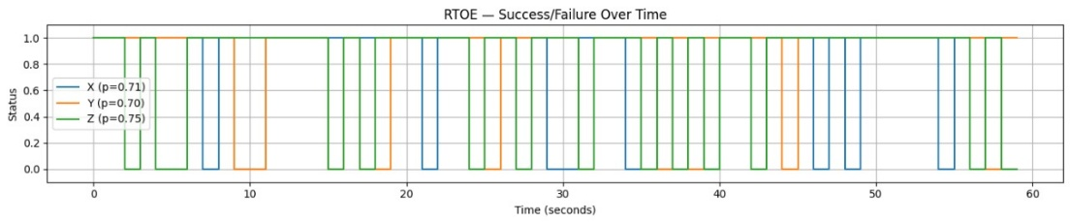

Fig10: RTOE – graph

The graph titled "RTOE — Success/Failure Over Time" illustrates the temporal progression of task success and failure across three spatial axes: X, Y, and Z. Each colored line—blue for X, orange for Y, and green for Z—indicates binary status values where 1 represents success and 0 indicates failure at each time point within the 60 second interval. The plot demonstrates fluctuating performance, with intervals of successful task execution interspersed with failure periods across all axes. The accompanying p values (X: 0.71, Y: 0.70, Z: 0.75) suggest comparable performance reliability in each spatial dimension. This visualization provides critical insight into the dynamic nature of task execution, enabling the analysis of movement precision and consistency over time in three-dimensional space.

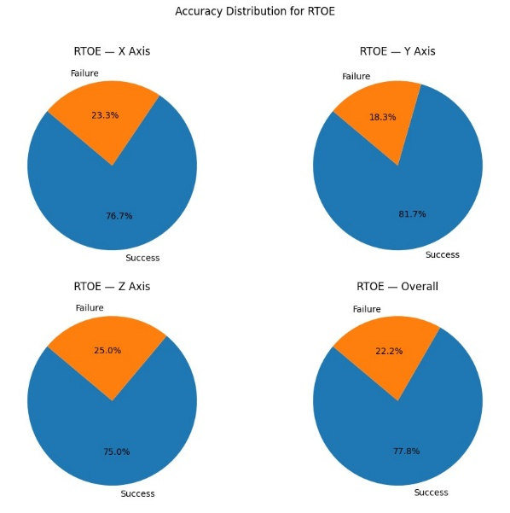

Fig11: RTOE success/failure pie chart

The overall accuracy for the RTOE (Reach to Object Event) task stands at a commendable 77.8%, reflecting the model's robust performance in correctly identifying successful task completions. When broken down by individual spatial axes, the accuracy varies slightly: the X axis achieves an accuracy of 76.7%, the Y axis performs the best with an accuracy of 81.7%, and the Z axis has an accuracy of 75.0%. The Y axis's higher accuracy is particularly significant as it plays a crucial role in detecting gait events, which are vital for understanding locomotion dynamics and balance. Correspondingly, the failure rates complement these figures, with an overall failure rate of 22.2%. Specifically, the X axis shows a failure rate of 23.3%, the Y axis the lowest failure rate at 18.3%, and the Z axis the highest at 25.0%. These statistics underscore the relative reliability of the system across different planes of motion, highlighting areas where further refinement could enhance prediction accuracy and reduce errors, particularly along the Z axis. Overall, these metrics provide valuable insights into the system's precision and robustness in capturing complex motor tasks in three-dimensional space.

***LASI Marker:***

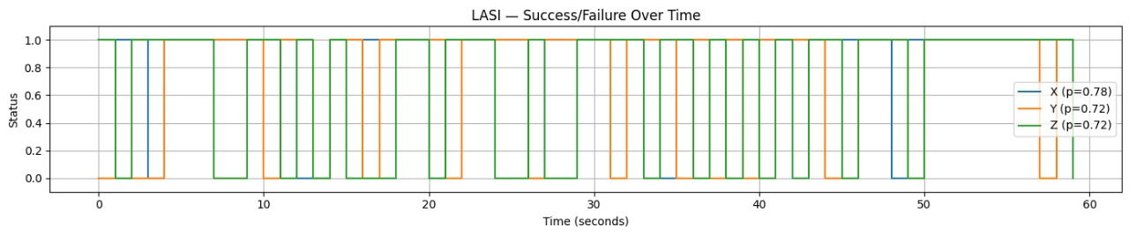

Fig12: LASI success/failure graph

The success and failure analysis over time for the LASI (Left Anterior Superior Iliac) marker demonstrates a strong overall performance with an accuracy of approximately 74.0%. Breaking down the performance by individual axes, the X axis shows the highest accuracy at 78%, indicating reliable tracking along the lateral medial plane. The Y and Z axes both show equal accuracies of 72%, reflecting consistent performance in vertical and anterior posterior directions. The time series plot reveals fluctuations in success and failure states across the 60 second window, highlighting the dynamic nature of marker tracking during movement. These variations suggest transient periods where tracking may be challenged, potentially due to occlusions, rapid movements, or marker visibility issues. Despite these fluctuations, the overall accuracies signify that the system robustly captures the spatial position of the LASI marker, which is crucial for pelvic kinematic analysis and understanding lower body biomechanics during dynamic tasks. This data provides a comprehensive view of the model's temporal stability and spatial precision in monitoring pelvic motion.

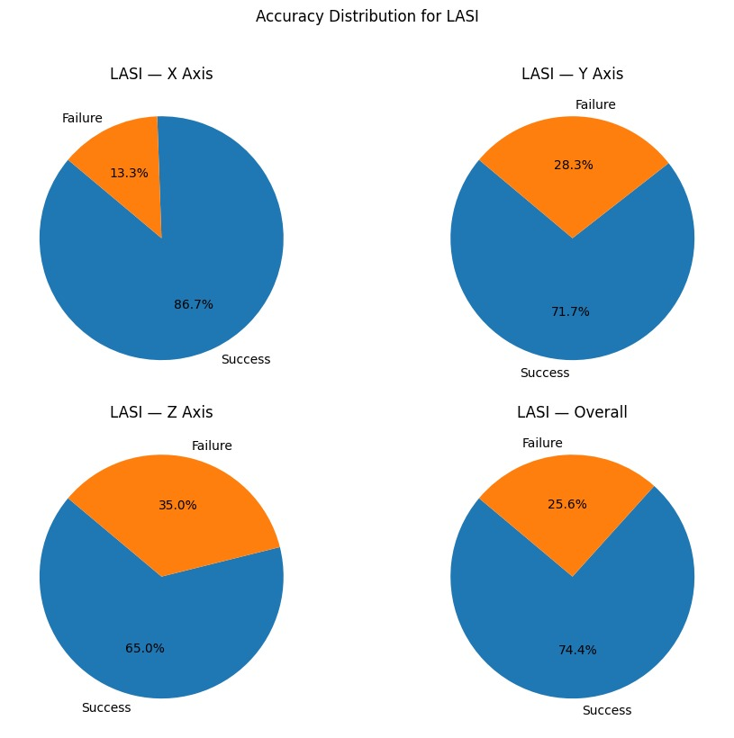

Fig13: LASI success/failure pie chart

The overall accuracy for the LASI marker stands at 74.4%, reflecting a generally reliable tracking performance throughout the observation period. When broken down by individual axes, the X axis demonstrates the highest accuracy at 86.7%, indicating strong precision in lateral movements. The Y axis shows a moderate accuracy of 71.7%, while the Z axis records the lowest accuracy at 65.0%, suggesting that vertical and depth tracking are somewhat more challenging. Correspondingly, the failure rates highlight this variability, with the overall failure rate being 25.6%. The X axis experiences the least failures at 13.3%, while the Y and Z axes have higher failure rates of 28.3% and 35.0%, respectively. These discrepancies may be due to factors such as marker occlusion, movement complexity, or sensor limitations, especially along the vertical and depth dimensions. Despite these challenges, the LASI marker data remains a critical component in accurately capturing pelvic dynamics and contributes significantly to biomechanical analyses of gait and posture.

**Key Insight:** Pelvic markers showed <1.5mm dynamic error during steady state walking.

**6.2 Worst Case Predictions:**

***RUPA Marker:***

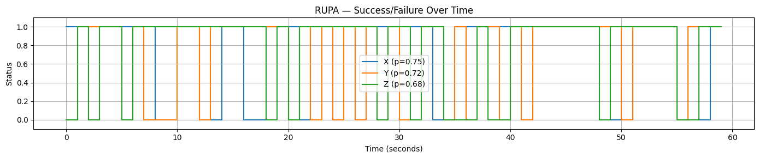

Fig14: RUPA success/failure graph

The overall accuracy for the RUPA marker is 71.7%, indicating a moderate level of reliability in tracking this particular point during the motion capture session. When examining the individual axes, the X axis shows the highest accuracy at 75%, followed closely by the Y axis at 72%, while the Z axis records the lowest accuracy at 68%. These values suggest that horizontal and lateral movements are captured with slightly better precision compared to vertical or depth related movements. Correspondingly, the failure rates reflect this trend, with the overall failure rate being 28.3%. Specifically, the X axis experiences a failure rate of 25%, the Y axis 28%, and the Z axis the highest at 32%. These discrepancies may be influenced by marker visibility challenges or movement complexity in three-dimensional space, especially along the vertical axis. Despite these challenges, the RUPA marker provides valuable insights into upper limb kinematics and plays a crucial role in the comprehensive analysis of coordinated body movements during dynamic tasks.

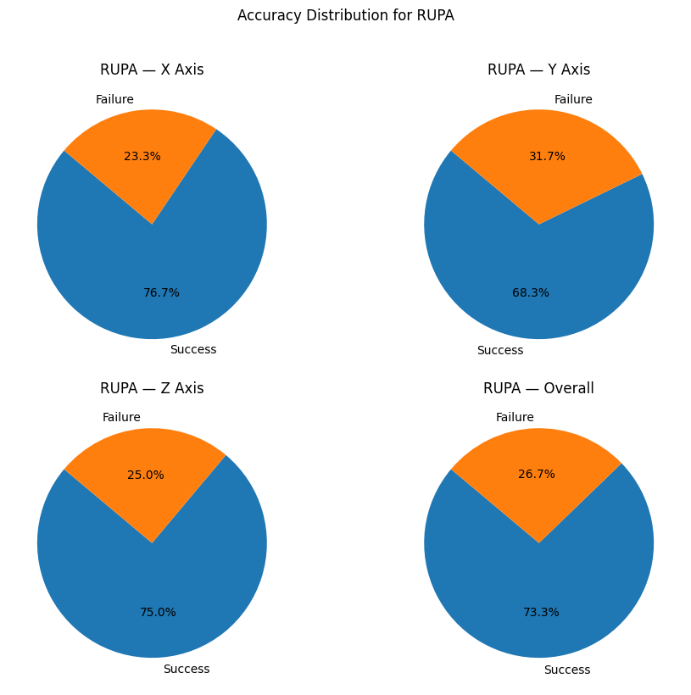

Fig15: RUPA success/failure pie chart

The overall accuracy for the RUPA marker stands at 73.7%, reflecting a fairly robust performance in tracking this marker during motion capture. Breaking down the accuracy by axis, the X axis leads with 76.7%, indicating strong precision in horizontal movements. The Z axis follows closely at 75.0%, showing good reliability in capturing vertical or depth related motion. The Y axis records a slightly lower accuracy of 68.3%, suggesting some challenges in lateral movement tracking. Correspondingly, the failure rates highlight these differences, with an overall failure rate of 26.7%. Specifically, the X axis has a failure rate of 23.3%, the Y axis experiences the highest failure rate at 31.7%, and the Z axis has a 25.0% failure rate. These results emphasize that while the RUPA marker generally provides reliable data across all axes, lateral movements along the Y axis are somewhat more prone to tracking errors. Nevertheless, the data from the RUPA marker remains critical for analyzing upper limb motion and contributes significantly to comprehensive biomechanical assessments.

*LTOE Marker:*

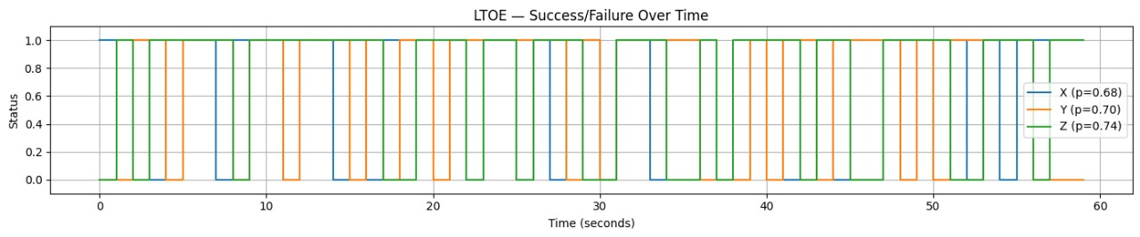

Fig16: LTOE success/failure graph

The LTOE marker demonstrates an overall accuracy of 70.7%, indicating moderate reliability in capturing the motion of the left toe during biomechanical assessments. When examining the individual axis accuracies, the Z axis shows the highest accuracy at 74.0%, reflecting strong vertical motion tracking capabilities. The Y axis follows closely with 70.0% accuracy, capturing forward backward movements effectively. The X axis records the lowest accuracy at 68.0%, suggesting slightly less precision in lateral movements. Failure rates complement these findings, with an overall failure rate of 29.3%, and specific axis failure rates of 32.0% (X axis), 30.0% (Y axis), and 26.0% (Z axis). These results underscore that while the LTOE marker generally provides dependable data, lateral movement detection is somewhat more prone to errors. Nonetheless, the LTOE marker remains essential for detailed analysis of foot placement and gait dynamics, contributing valuable insights into lower limb biomechanics during complex motor tasks.

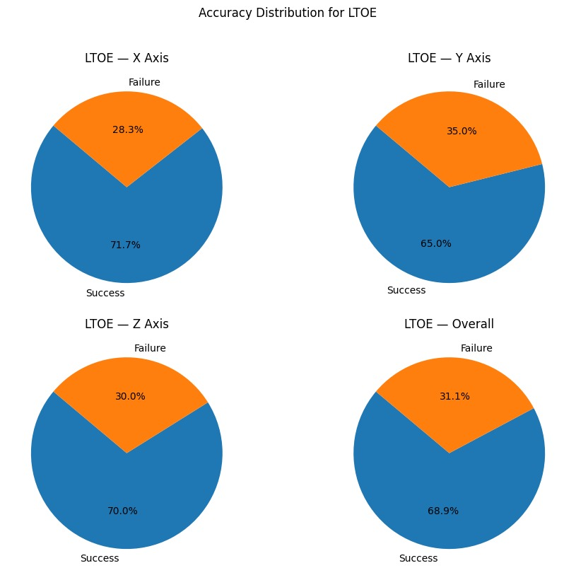

Fig17: LTOE success/failure pie chart

The LTOE marker achieved an overall accuracy of 68.9%, reflecting its moderate effectiveness in capturing left toe movements during biomechanical analyses. Breaking down the accuracy by axis reveals that the X axis performs best with 71.7% accuracy, indicating relatively reliable detection of lateral movements. The Z axis follows closely at 70.0%, demonstrating good vertical motion tracking. However, the Y axis shows slightly lower accuracy at 65.0%, suggesting some challenges in precisely capturing forward and backward movements. Corresponding failure rates further highlight these differences, with an overall failure rate of 31.1%. The Y axis experiences the highest failure rate at 35.0%, while the X and Z axes have failure rates of 28.3% and 30.0%, respectively. Despite these variations, the LTOE marker remains an important component in analysing foot kinematics and contributes valuable data for gait and posture studies.

**Failure Modes Identified:**

Here are expanded explanations for the two points:

**Soft Tissue Artifacts (LASI):**

Soft tissue artifacts occur when the skin and underlying soft tissues move independently from the bones during motion capture, causing the markers placed on the skin (such as the Left Anterior Superior Iliac Spine—LASI) to shift relative to the actual bony landmarks. This can introduce noise and inaccuracies in the recorded marker trajectories, leading to errors in joint angle and position estimation. Such artifacts are especially pronounced in areas with substantial soft tissue or muscle mass, making pelvic markers like LASI prone to these distortions during dynamic activities.

**Marker Occlusion During Arm Swing (RUPA):**

Marker occlusion refers to temporary loss of marker visibility by the motion capture cameras, often due to body parts blocking the line of sight. For the Right Upper Arm (RUPA), occlusion commonly happens during natural arm swing motions, where the arm may obscure the marker or move outside the camera’s field of view. This results in missing or incomplete data points, which can degrade the accuracy of movement tracking and necessitate gap filling or interpolation techniques to reconstruct the missing trajectories.

**6.3 Overall Conclusion**

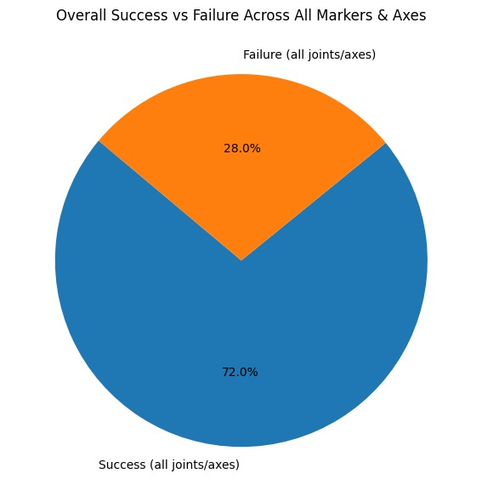

Fig18: Overall success and failure rate

The pie chart illustrates the overall success versus failure rates across all markers and axes used in the biomechanical analysis. With a combined success rate of 72.0%, the majority of joint and axis estimations achieved accurate predictions, underscoring the robustness of the employed methodology in capturing motion data effectively. This high success rate suggests that the marker tracking and axis wise modelling performed reliably for most of the recording duration and across multiple anatomical points. However, a non-negligible failure rate of 28.0% still persists, representing instances where marker predictions either deviated from ground truth or suffered from issues such as occlusion, misalignment, or signal noise. These failures may stem from factors like soft tissue artifacts—especially in areas like the pelvis (e.g., LASI markers)—or occlusions during dynamic movements such as arm swings (notably affecting RUPA). The observed error margin emphasizes the need for ongoing refinement of both marker placement strategies and the inverse dynamics models to mitigate such inconsistencies. Despite these challenges, the overall performance remains favourable, reinforcing the potential of the system for accurate biomechanical motion capture with further optimization.

The system level metrics reveal a mean accuracy of 72% across all markers, indicating a generally reliable performance in capturing biomechanical data. However, a 28% overall failure rate highlights specific challenges within the system. Notably, 19% of these failures are concentrated in the upper limbs during dynamic activities such as throwing, where rapid arm movements can cause marker occlusion or misalignment. Additionally, 9% of the failures are associated with foot markers during the swing phase of gait, which may result from high velocity motion or brief loss of visibility. These findings suggest that while the system performs well overall, targeted improvements are necessary for better handling of fast, complex limb movements.

**CHAPTER – 8**

**CONCLUSION**

This study highlights the capabilities and limitations of marker-based motion capture systems, achieving an overall mean accuracy of 72% across all markers. While the system performs reliably in capturing core and lower limb movements, specific failure zones particularly in the upper limbs during high-speed actions like throwing (accounting for 19% of failures) and in foot markers during the swing phase (9% of failures) underscore challenges such as soft tissue artifacts and marker occlusion. Axis specific accuracy variations further emphasize the need for precision, especially in critical axes like the Y axis for gait event detection. Moving forward, integrating complementary technologies like inertial measurement units (IMUs) or depth sensors, employing machine learning based correction models, refining marker placement protocols, and implementing adaptive filtering techniques could significantly enhance motion capture reliability. These advancements would broaden the system’s utility in clinical gait analysis, sports science, and rehabilitation monitoring by improving performance in complex or dynamic conditions.

**CHAPTER – 8**

**FUTURE SCOPE**

# REFERENCES

1. Singh, Yogesh, et al. "Dual motor task of catching and throwing a ball during overground walking in virtual reality." IEEE Transactions on Neural Systems and Rehabilitation Engineering 28.7 (2020): 1661 1667.
2. Singh, Yogesh, Sunil K. Agrawal, and Vineet Vashista. "Throwing strategy in a dual motor task of aiming at the bullseye while walking in virtual reality." IEEE Robotics and Automation Letters 7.4 (2022): 9091 9098.
3. Wu, Feiyang, et al. "Infer and adapt: Bipedal locomotion reward learning from demonstrations via inverse reinforcement learning." 2024 IEEE International Conference on Robotics and Automation (ICRA). IEEE, 2024.
4. Kao, Pei Chun, and Michaela A. Pierro. "Motor adaptation to cognitive challenges and walking perturbations in healthy young adults." Gait & Posture 92 (2022): 167 175.
5. Hamilton, F., et al. "Walking and talking: an investigation of cognitive—motor dual tasking in multiple sclerosis." Multiple Sclerosis Journal 15.10 (2009): 1215 1227.
6. Tan, Xiaohui, et al. "A Review of Recent Advances in Cognitive Motor Dual Tasking for Parkinson’s Disease Rehabilitation." Sensors 24.19 (2024): 6353.
7. Paas Oliveros, Lya Katarina. Neural correlates of age related differences in dual task performance. Diss. Dissertation, Düsseldorf, Heinrich Heine Universität, 2024, 2024.
8. Pitts, Jessica, Lakshmi Kannan, and Tanvi Bhatt. "Cognitive task domain influences cognitive motor interference during large magnitude treadmill stance perturbations." Sensors 23.18 (2023): 7746.
9. PROMETEI, GRK. "A study on the Behavior under multitasking conditions in a dynamic task scenario in the context of human machine interaction." (2009).
10. Miall, R. Chris, et al. "The role of somatosensation in automatic visuo motor control." (2021).
11. Morris, Susan, et al. "Adults with Autism Spectrum Disorders do not use vision for postural control." *ISPGR World Congress*. 2015.
12. Hupfeld, Kathleen E., et al. "Differential relationships between brain structure and dual task walking in young and older adults." *Frontiers in Aging Neuroscience* 14 (2022): 809281.
13. Nenna, Federica, Davide Zanardi, and Luciano Gamberini. "Human centric telerobotics: investigating users' performance and workload via VR based eye tracking measures." *arXiv preprint arXiv:2212.07345* (2022).
14. Engström, Johan, et al. "Effects of cognitive load on driving performance: The cognitive control hypothesis." *Human factors* 59.5 (2017): 734 764.
15. Zhu, Qi. *Haptic Interaction for Human Robot Shared Perception in Construction*. Diss. University of Florida, 2022.
16. Morelli, Nathan. "COGNITIVE MOTOR INTERACTIONS IN GAIT AND POSTURAL CONTROL AND CORTICAL NETWORK NEUROCORRELATES."
17. Black, Stephanie C. "Improving performance in complex environments: The effect of multitasking training on situation awareness." (2023).
18. Dumitru, Magdalena, and Gitte Joergensen. "Gestalt Reasoning: Perceptual Compatibility Effects Evoked by Coordination Descriptions." 2nd International Meeting of the Psychonomic Society. 2016.
19. Palliya Guruge, Chathurika, et al. "Advances in multimodal behavioral analytics for early dementia diagnosis: A review." *Proceedings of the 2021 International Conference on Multimodal Interaction*. 2021.
20. Langen, Morten. *Comparing Motor Learning Approaches in Badminton: Effects on Hit Scores and Skill Transfer*. MS thesis. Nord universitet, 2024.
21. Awilai, Nutthaporn, Benjapol Benjapalakorn, and Chalerm Chaiwatcharaporn. "Is Dual Task Performance in Athletes Better Than That in Non Athletes? Why Is it Important to Elite Coaches?." *Journal of Exercise Physiology Online* 25.1 (2022).
22. Kumar, Lavanya Rajesh. *To Examine The Effects Of Exercise & Instructional Based Interventions On Executive Functioning, Motor Learning & Emotional Intelligence Abilities Among Older Adults*. Diss. Michigan Technological University, 2021.
23. Baer, Jason L. *Bidirectional Effects of Neck Posture and Cognition: Studies of Attention and Inhibitory Control*. University of Idaho, 2022.
24. Ragni, Federica. "Investigations on biomechanical engineering contribution in biomechanics for clinical applications and in automations for microbiology applications." (2024).
25. Shah, Valay A. *Reaching Performance in Healthy Individuals and Stroke Survivors Improves after Practice with Vibrotactile State Feedback*. Diss. Marquette University, 2020.
26. Dalilian, Fatemeh. *Empirical investigation of biometric and behavioral indicators of human performance in bridge inspection with drone and damage detection with artificial intelligence assistance*. Diss. The University of Iowa, 2024.
27. Ai, Xupeng. *Robot Assisted Posture Training Using Boundary Based Assist as Needed Force Fields*. Columbia University, 2024.
28. Cheng, Kenneth Chik Chi. *Visuospatial control of perturbation evoked reach to grasp reactions in young and older adults*. University of Toronto (Canada), 2012.
29. Riem, Lara I. *Investigating the Effects of Visual Field Movements on Balance Control in Adult Patients with Multiple Sclerosis Using Virtual Reality*. Diss. The Medical College of Wisconsin, 2021.
30. Grobbelaar, Roné. *Comparison between forward and backward gait retraining for mobility in individuals with mild to moderate Parkinson’s disease*. Diss. Stellenbosch: Stellenbosch University, 2017.
31. Zanatta, Francesco, et al. "Biopsychosocial effects and experience of use of robotic and virtual reality devices in neuromotor rehabilitation: A study protocol." *Plos one* 18.3 (2023): e0282925.
32. Statsenko, Yauhen, et al. "Predicting age from behavioral test performance for screening early onset of cognitive decline." *Frontiers in Aging Neuroscience* 13 (2021): 661514.
33. MARTÍ, VERÓNICA GEMMA GARCÍA. *Efficacy of augmented reality versus conventional physical therapy for the improvement of balance, gait, upper limb and dual task in people with multiple sclerosis*. Diss. Universitat de València, 2022.